nm
COURSE CODE: 24SDCS02 / 24SDCS02E / 24SDCS02P / 24SDCS02L FULL STACK APPLICATION DEVELOPMENT

NAME:M.PRAVEEN REDDY ID:2400032662

#SKILL - 5 ➔ Spring Autowiring Demo using @Autowired
Prerequisites:
- General Idea on Spring Framework
- Modules of Spring Framework
- Understanding of Autowiring concepts

A college application maintains student information along with their certification details. The Student object contains a Certification object, and instead of creating this Certification object manually, Spring should automatically provide it using the @Autowired annotation. When the required classes are marked with @Component, Spring creates their objects and manages them inside the IoC container. Using @Autowired, the Certification object is supplied to the Student object by Spring without using the new keyword, allowing both objects to be linked through annotation-based configuration.

Tasks:
- Create a Certification class with fields such as id, name, and dateOfCompletion.
- Create a Student class with fields such as id, name, gender, and a Certification object.
- Annotate both classes with @Component to enable Spring detection.
- Use @Autowired on a field, constructor, or setter inside the Student class to inject the Certification object.
- Configure component scanning using either:
  - An XML configuration file
  - A Java configuration class with @Configuration and @ComponentScan
- Load the Spring IoC container using ApplicationContext.
- Retrieve the Student bean and print all details, including the injected Certification object.
- Push the Spring project to GitHub.

Appconfig:
package com.klu.config;

import org.springframework.context.annotation.ComponentScan;
import org.springframework.context.annotation.Configuration;

@Configuration
@ComponentScan(basePackages="com.klu.model")
public class AppConfig {

}
MainApp
package com.klu.main;

import org.springframework.context.ApplicationContext;
import org.springframework.context.support.ClassPathXmlApplicationContext;

import com.klu.model.Order;
import com.klu.model.Product;

public class MainApp {
public static void main(String[] args) {

ApplicationContext ctx =
new ClassPathXmlApplicationContext("applicationContext.xml");

Product p1 = (Product) ctx.getBean("p1");
p1.display();

Product p2=(Product) ctx.getBean("p2");
p2.display();

Order o1 = (Order) ctx.getBean("o1");
o1.display();
}
}
Products
package com.klu.model;

public class Order {

private int orderId;
private String customerName;
private int quantity;
private Product product;

public Order(int oi, String cn, int q) {
this.orderId = oi;
this.customerName = cn;
this.quantity = q;
}

public void setProduct(Product product) {
this.product = product;
}

public void display() {
System.out.println("Order Details:");
System.out.println("Order ID : " + orderId);
System.out.println("Customer Name : " + customerName);
System.out.println("Quantity : " + quantity);

System.out.println("Product Details:");
System.out.println("Product ID : " + product.getProductId());
System.out.println("Product Name : " + product.getProductName());
System.out.println("Category : " + product.getCategory());
System.out.println("Price : " + product.getPrice());
}
}
Products
package com.klu.model;

public class Product {

private int productId;
private String productName;
private String category;
private double price;

public Product(int pid, String pn, String c, double p) {
this.productId = pid;
this.productName = pn;
this.category = c;
this.price = p;
}

public int getProductId() {
return productId;
}

public String getProductName() {
return productName;
}

public String getCategory() {
return category;
}

public double getPrice() {
return price;
}

public void display() {
System.out.println("Product [ID=" + productId + ", Name=" + productName +
", Category=" + category + ", Price=" + price + "]");
}
}
GITHUB
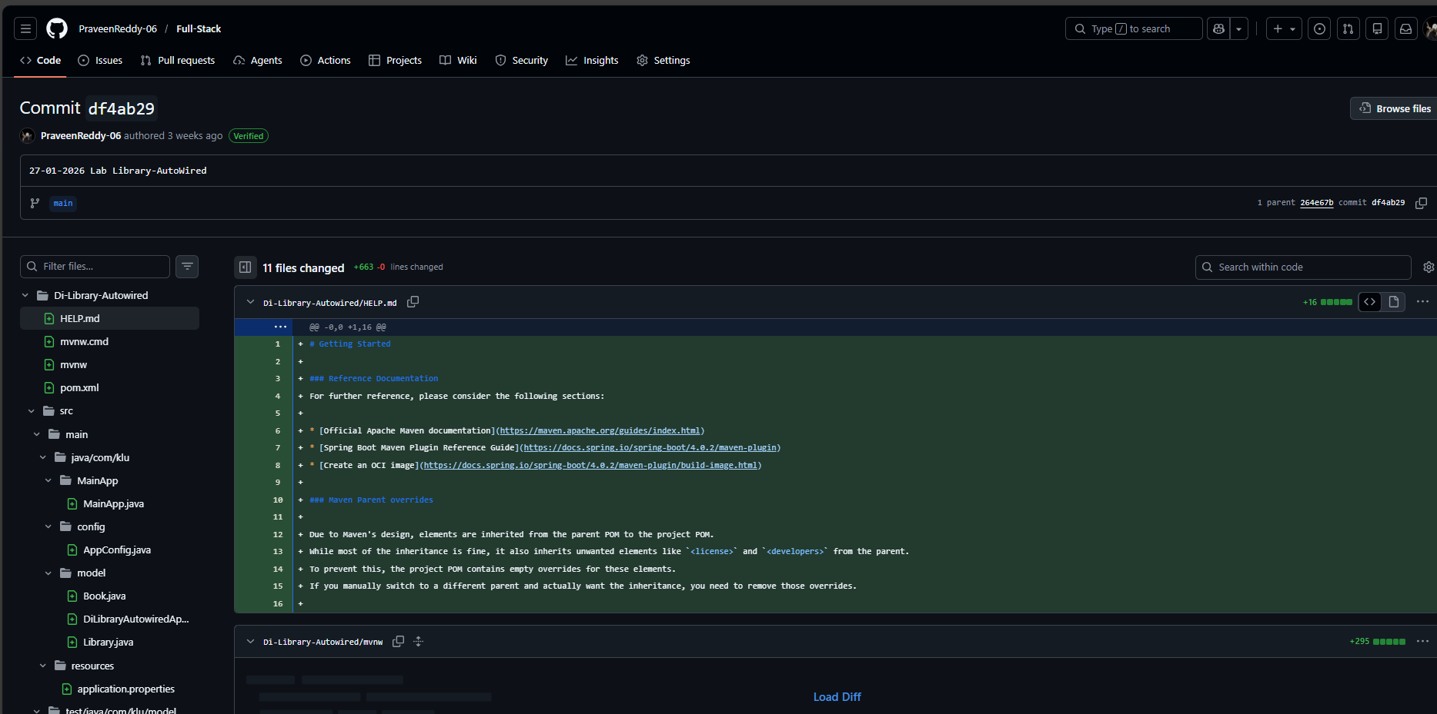
OUTPUT
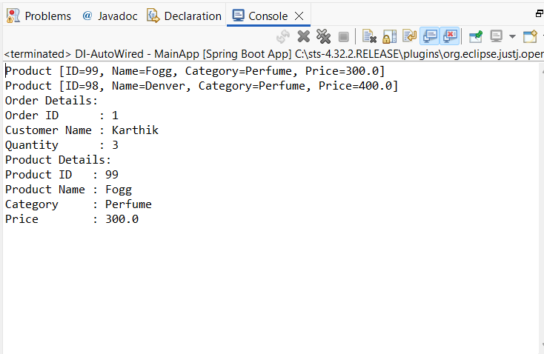

VIVA QUESTIONS:
1. What is autowiring in Spring?
Autowiring is a feature in the Spring Framework that automatically injects required dependencies into a bean without explicit configuration. Spring resolves and connects collaborating objects at runtime.

2. What is the purpose of the @Autowired annotation?
@Autowired tells Spring to automatically inject a matching bean into a field, constructor, or setter method. It removes the need for manual wiring in configuration files.

3. How does Spring choose which bean to inject?
Spring primarily matches beans by type.
If multiple beans of the same type exist, Spring then tries to match by name. Additional annotations like @Qualifier can be used to specify the exact bean.

4. What is component scanning in Spring?
Component scanning is the process where Spring automatically detects classes annotated with stereotypes such as:
- @Component
- @Service
- @Repository
- @Controller
and registers them as beans in the IoC container.

5. What happens if more than one bean matches the dependency type?
Spring throws a NoUniqueBeanDefinitionException because it cannot decide which bean to inject. This can be resolved by:
- Using @Qualifier to specify the bean
- Marking one bean as @Primary
- Injecting by bean name

(For Evaluator’s use only)

 | Comment of the Evaluator (if Any) |  | Evaluator’s Observation  Marks Secured: out of  EMP ID & Full Name of the Evaluator:  Signature of the Evaluator Date of Evaluation:

